## Lotus Flower Story Outline:

Theme:  
The theme of the story is about a journey for help and finding the courage to escape from abuse. The protagonist, the Princess, seeks help from her friends, family, and even the police but faces disappointment as she is unable to find anyone who can help her. The theme is about resilience and the importance of seeking help when in an abusive relationship.  
  
Tone: The tone of the story is a mixture of sadness, frustration, and hope. The Princess is in a difficult situation, and the tone reflects her feelings of desperation as she tries to find help. However, despite the obstacles she faces, the Princess continues to persevere and look for a way to escape from the abuse, which gives the story a hopeful tone.

Pacing: The pacing of the story is slow and deliberate. The story is a journey of discovery and reflection, and the pacing reflects the Princess's journey and her internal struggles. The story builds up slowly, with each disappointment and setback, until the climax when she finally finds the courage to escape from the abuse.

#### Discovering a Lost Past

A. Setting: Real world. Cold Winter. An all American white family living room

B. Characters: 5-year-old girl and her grandmother

C. The little girl finds a photograph of a woman and asks her grandmother who she is, leading to the grandmother telling her a story about the woman in the photograph - the little girl's mother.  
  
Interaction Summary: Gurtrude, a five-year-old girl, is sitting in her family's living room on a cold winter morning. The sun creeps in through the windows as she examines an old photograph of her mother that she found tucked away in a drawer. Intrigued, she turns to her grandmother for answers. Her grandmother looks at her with a gentle smile, and begins to tell the story of the woman in the photograph; a woman who endured an abusive marriage and found the courage to leave it all behind.

#### The Decision

A. Setting: Royal castle and kingdom

B. Characters: Princess and prince

C. Conflict: Protagonist Princess in an abusive relationship with the prince, struggles to find the courage to leave her life of royalty behind

D. The abuse is shown through the prince's angry and violent behavior towards the princess and her struggle to cope with the abuse and feelings of oppression.

The morning sun rises as the Princess lies in her castle bed, listening to the angry pounding of the prince's fist against her door. She feels trapped and helpless, like a prisoner in her own home under the prince's oppressive rule. But within her, a spark of bravery begins to flicker, and she musters the courage to escape through the window and flee towards the safety of the forest. Her friends, the Giggle Worms, await her there - a small but welcomed glimmer of hope in an otherwise darkening landscape.

The Giggle Worms, small in size but big in heart, are always eager to offer their support and friendship to the Princess. Their village is just a short distance away from the castle, and as she sets foot in the forest, a newfound determination begins to swell within her. She knows that with their help, she can break free from this darkness and find a brighter future, one in which she never has to wake up in her castle bed again.

But the prince's voice soon follows her, echoing through the forest as he vows to come after her. Despite this threat, the Princess trudges on, determined to reach the safety of the Giggle Worms' village - and a new beginning.

#### **Village of Friends**

Seeking Help from her friends (Giggle Worms)

A. The princess meets Giggle Worms in the forest

B. Giggle Worms unable to help because they are easily distracted

C. The princess leaves disappointed.  
  
Interaction Summary: As the Princess arrives in the village of the Giggle Worms, she is greeted by a chorus of joyful giggles. The tiny creatures, who view the Princess as their beloved friend and royalty, immediately stop their play and gather around her, with some seen exiting their worm house. They listen intently as she shares her story of the escalating violence in the castle and the fear she lives in. Despite the normally happy and lighthearted nature of the Giggle Worms, they take the Princess' words to heart, their expressions turning serious. However, as she continues her story, a butterfly flutters by, catching the eye of the closest Giggle Worm. The creature's face lights up with delight, and it begins to giggle and chase the butterfly. In moments, the rest of the Giggle Worms are caught up chasing their own butterflies in their playful nature, giggling in unison and following the butterflies as it leads them on a joyful dance. . It starts giggling and chasing the butterfly, and soon enough, the rest of the Giggle Worms are caught up in their playful nature once again, giggling and scattered. The Princess decides to go see the Huggies. They always had time for her.

* Show the Princess's fear and desperation through her body language and facial expressions, while also highlighting the carefree and lighthearted nature of the Giggle Worms.
* Use the contrast between the joyful sounds of the Giggle Worms' village and the tense and emotional atmosphere of the Princess's story to create a stark difference.
* Have the Princess's voice shake and falter as she speaks, to emphasize the weight of her situation and her emotional state.
* Show the Giggle Worms' reactions to the Princess's story, transitioning from joyful to serious and concerned.
* Use close-ups of the Giggle Worms' faces to show their reactions and emotions, highlighting the innocence and lack of understanding of the situation.

#### Family Home

A. The princess visits her family home

B. Hugs unable to help because they believe it's a private matter

C. The princess leaves disappointed

Interaction Summary:  
The Princess arrives at her family's lake cottage and finds Grandpa Huggy out fishing. He rows to shore and greets her, and they start walking to the cottage. She begins to share with him about the escalating violence from the prince, but as she's talking, she suddenly feels a sharp pain and crumples to the ground. Grandpa Huggy rushes to her side, and she reveals to him that she's pregnant with the prince's child. He's shocked and upset, but also determined to help her in any way he can. As they enter the cottage, Grandpa Huggy asks her to start over and share her story with them both. She tells him and Grandma Huggy about the prince and how he has been subjecting her to violence. Grandma and Grandpa Huggy listen intently, their eyes showing the pain they feel. When she tells almost everything, they stop her and ask to share what they think. She is desperate to hear what they think and possible solutions. But her heart drops when Grandma and Grandpa Huggy start to tell her that 'everyone goes through these things' and even share their own struggles they faced as a couple. The princess looks down in despair and the underlying message is that she is looking for a way out. They offer to pray with her about it. We don't see her response. Cut to outside the princess walking away from the cottage. Grandma and Grandpa Huggy telling her to give it some time and she leaves the cottage with a disappointed look on her face. Grandma and Grandpa Huggy stand in front of the cottage, holding each other as the princess walks away.

#### Seeking Help from Cops (Stackers)

A. The princess visits a fortress near a river

B. Stackers are militant and spring into action quickly by stacking on top of each other, making a giant version of itself. get ready to help her unable to help because they need physical proof of abuse

C. The princess leaves disappointed

Interaction Summary: The Princess arrives at the fortress, breathing heavily. She is confronted by a group of Stackers who ask for her reason for being there. As she explains that the prince has been abusing her, the Stackers quickly take action and escort her across the drawbridge into the fortress. In the War Room, the Princess begins to share her story. She is amazed when she sees the Stackers stack on top of each other to create a giant version of themselves, exhibiting incredible strength and coordination. The Circle requests proof, and the Princess reluctantly explains how the prince threw something at her but missed. However, the Stackers tell her that they cannot act on such limited information and take note of her story, promising to help if the abuse continues. The Princess could have emotional outbursts during her interactions with her Stackers, showing the distress and fear she is experiencing. But they still cannot help. The Princess, disappointed, leaves the fortress and walks away into the night.

Finding Strength within herself

A. The princess sits alone in the forest, feeling hopeless

B. The princess sees a blooming lotus flower and finds the strength to leave everything behind and start a new life.

Interaction Summary:

The Princess is sitting in the forest, feeling hopeless and lost. She has been through a lot, seeking help from her friends, family, and even the police, but has been left disappointed each time. Suddenly, she notices a blooming lotus flower nearby, and as she looks at it, she feels a sense of peace wash over her. The lotus flower symbolizes her journey, representing the struggles she has faced and the strength she has found within herself to overcome them. The Princess stands up, takes a deep breath, and walks away from the forest and into town ready to start the next chapter in her life.

**Public Declaration**

A. The princess decides to go public with her story of abuse and renounces her title as princess.

B. The princess's story resonates with the people of the kingdom, and she becomes an advocate for victims of abuse.

C. The prince is publicly shamed and discredited, and the princess's bravery empowers other victims of abuse to speak out.

**The Aftermath**

A. Setting: 1981, Family Living Room

B. Characters: 5 year old little Girl, Grandmother

C. The story returns to the setting of the family living room in 1981. The little girl is excitedly talking about the princess and her story, but the grandmother has a regretful look on her face and the little girl can't understand why.

D. The grandmother asks the little girl to come closer. The grandmother lifts the little girl's pant leg and exposes a massive long-healed burn on her leg. She explains that this burn is a result of the fire set by the prince, who was the abuser of the princess in the previous story.

She explains that the princess left the castle because she had a baby and she didn't want that baby to be born in those conditions. That baby was the little girl.

The prince eventually found them, and shortly after, he set a fire that consumed everything the princess and her family had built in their new life. Her mother died saving her.

She shows the little girl a newspaper article with a picture of the prince, in modern times, in the real world, dressed in a suit, standing at a podium surrounded by supporters holding signs with the princess's last name on them.  
  
Interaction Summary:  
The setting returns to the family living room in 1981. The little girl is excitedly talking about the princess from the previous story, but the grandmother has a regretful look on her face. The grandmother lifts the little girl's pant leg and shows her a large long-healed burn, explaining that it was a result of the fire set by the prince who was the princess's captor. The grandmother reveals that the princess was her mother and the little girl was the baby she had to leave the castle to protect. The prince eventually found them and set a fire that took everything and killed the princess's mother. The grandmother shows the little girl a newspaper article with a picture of the prince, dressed in a suit, standing at a podium surrounded by supporters holding signs with the princess's last name.

#### How her situation is revealed

**Giggle Worms:**

After arriving at the village The Princess opens up, this is where the viewer hears her worries and fears of how bad things can get for her with the prince. For a moment, the Giggle Worms listen attentively, offering comforting words and a listening ear. The Princess feels a weight lifted off her shoulders as she talks and realizes that she's not as alone as she once thought until the butterflies appear and grab their attention. First, it is just a single butterfly who captures the attention of a single Giggle Worm. As she keeps continues, more butterflies show up and they are all distracted and chase the butterflies into the bush  
  
Show the Princess's fear and desperation through her body language and facial expressions, while also highlighting the carefree and lighthearted nature of the Giggle Worms.

Use the contrast between the joyful sounds of the Giggle Worms' village and the tense and emotional atmosphere of the Princess's story to create a stark difference.

Have the Princess's voice shake and falter as she speaks, to emphasize the weight of her situation and her emotional state.

Show the Giggle Worms' reactions to the Princess's story, transitioning from joyful to serious and concerned.

Use close-ups of the Giggle Worms' faces to show their reactions and emotions, highlighting the innocence and lack of understanding of the situation.

**Huggies:**

The Princess continues her journey, eventually arriving at the Huggies cottage.

When she suddenly feels dizzy and stumbles to her knees and Grandpa Huggy helps, this is when the viewer learns about her pregnancy. This moment must be handled with extreme care. What I The Huggies offer her a safe place to stay and take care of her, and she feels grateful for their kindness.

**Stackers:**

The Princess finally arrives at the Stacker village, where she is greeted by the friendly creatures. They offer her food and rest, and she gratefully accepts.

As she looks down at her body, she realizes that her bruises have healed and her scars are no longer bloody. She feels a sense of relief that she no longer has physical proof of the abuse she suffered at the hands of the prince. She also realizes that without evidence of the abuse, she may have a harder time convincing others of the danger she faces. Despite this, she feels grateful for the healing she has received and continues her journey with a sense of determination.  
  
Giggle Worms:

Huggies:

* Show the contrast between the warm and comforting atmosphere of the Huggies' cottage and the cold and oppressive environment of the castle.
* Use the moment of the Princess's collapse to create a shock and reveal her pregnancy, emphasizing the urgency of her situation.
* Show the Huggies' reactions to the Princess's story, transitioning from kind and understanding to regretful and helpless.
* Use background music to create an atmosphere of comfort and care, but also with an undercurrent of sadness and regret.
* Show the Princess's feelings of disappointment and frustration as the Huggies are unable to help her, but also her gratitude for their support.

Stackers:

* Show the contrast between the strength and military-like demeanor of the Stackers and the vulnerability and fear of the Princess.
* Use the Stackers' quick action and coordination to demonstrate their capability and willingness to help, but also their limitations in the face of a lack of physical proof.
* Show the Princess's frustration and disappointment as she realizes that the Stackers are unable to help her, but also her gratitude for their kindness and support.
* Use background music to create an atmosphere of determination and strength, but also with an undercurrent of disappointment and frustration.
* Show the Princess's emotional state as she leaves the Stackers' village, with her feelings of hopelessness and fear intensifying as she continues her journey.

# Environmental Concepts

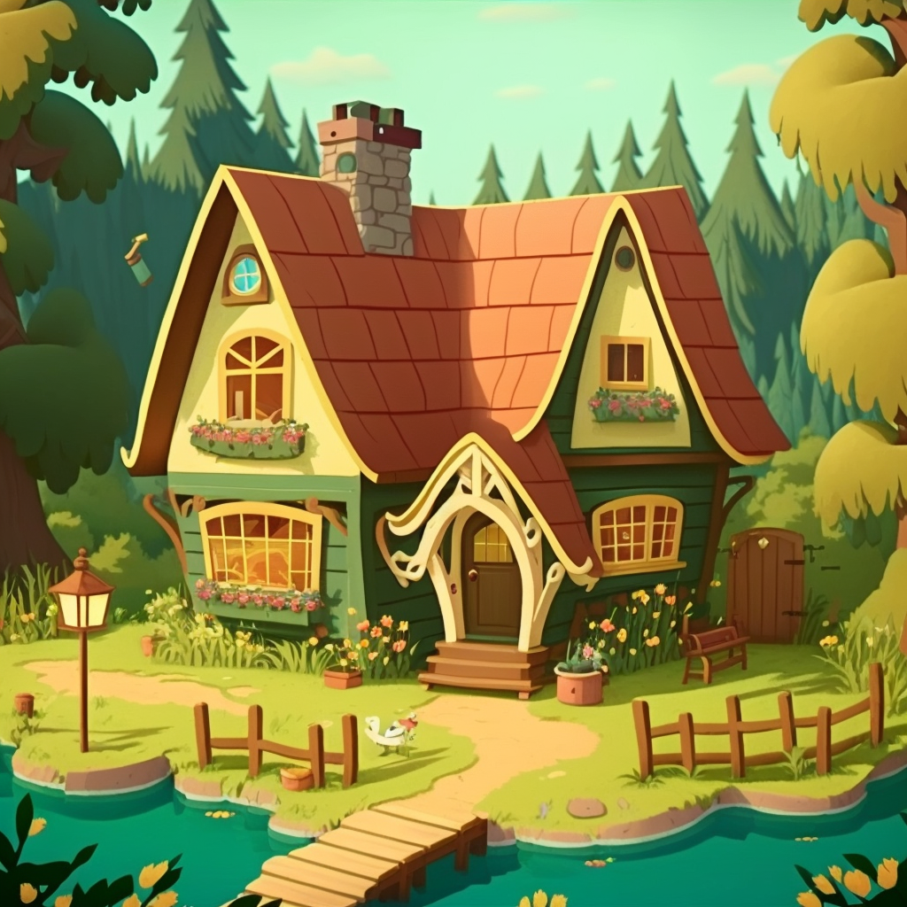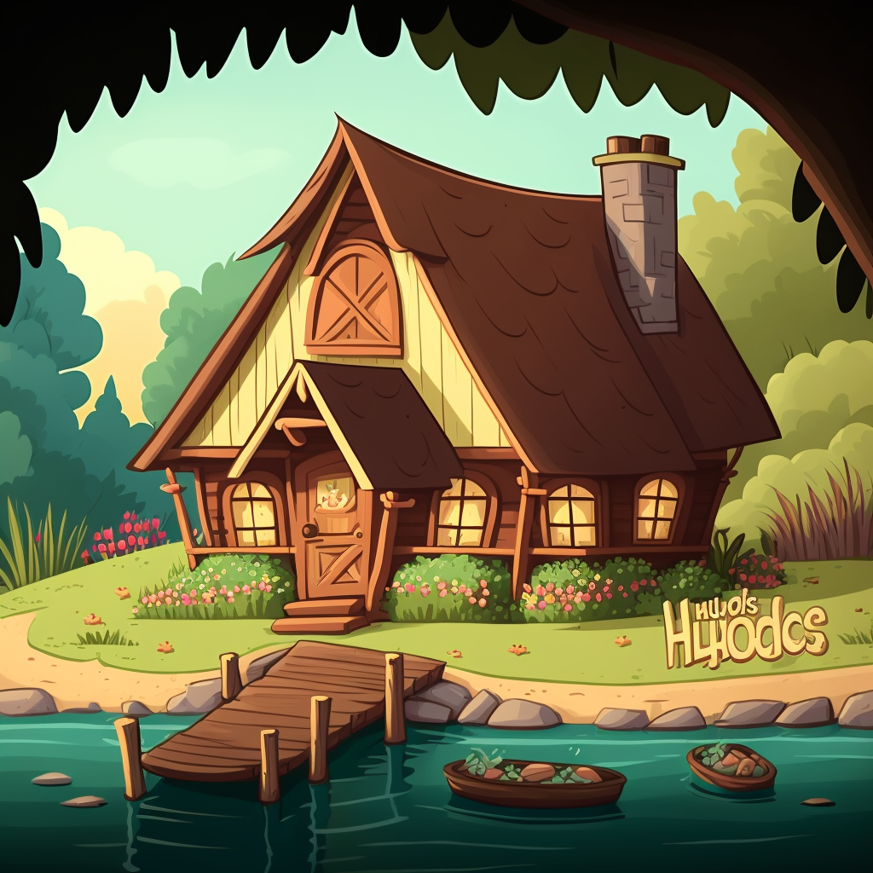  
Huggies' Cottage is a warm and cozy home, located by the side of a tranquil lake. It is a wooden structure with a thatched roof, surrounded by lush gardens and trees. The inside of the cottage is just as inviting, with comfortable furnishings, a crackling fireplace, and a warm, homely atmosphere.

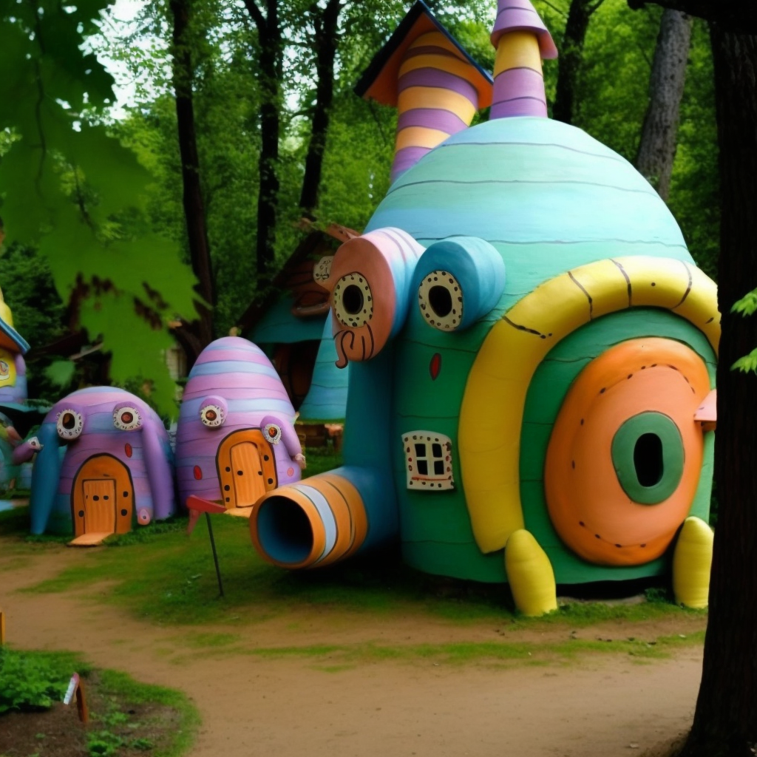

Giggle Worms' Village is a small and whimsical place, tucked away in the heart of the forest. It is a place of laughter, joy, and innocence, where the Giggle Worms, small and playful creatures, live. The village is made up of tiny houses and huts, all painted in bright colors and adorned with flowers. The village is surrounded by lush greenery, and the sun shines down on it, making it a warm and inviting place.

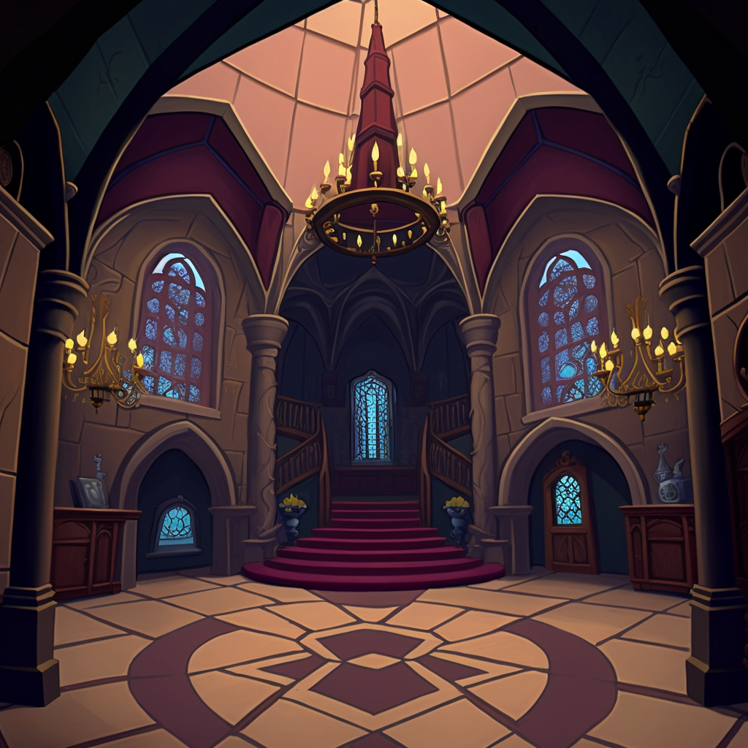

This is outside the Princess’s room. This is where the prince will bang on her door.

# Character Concepts

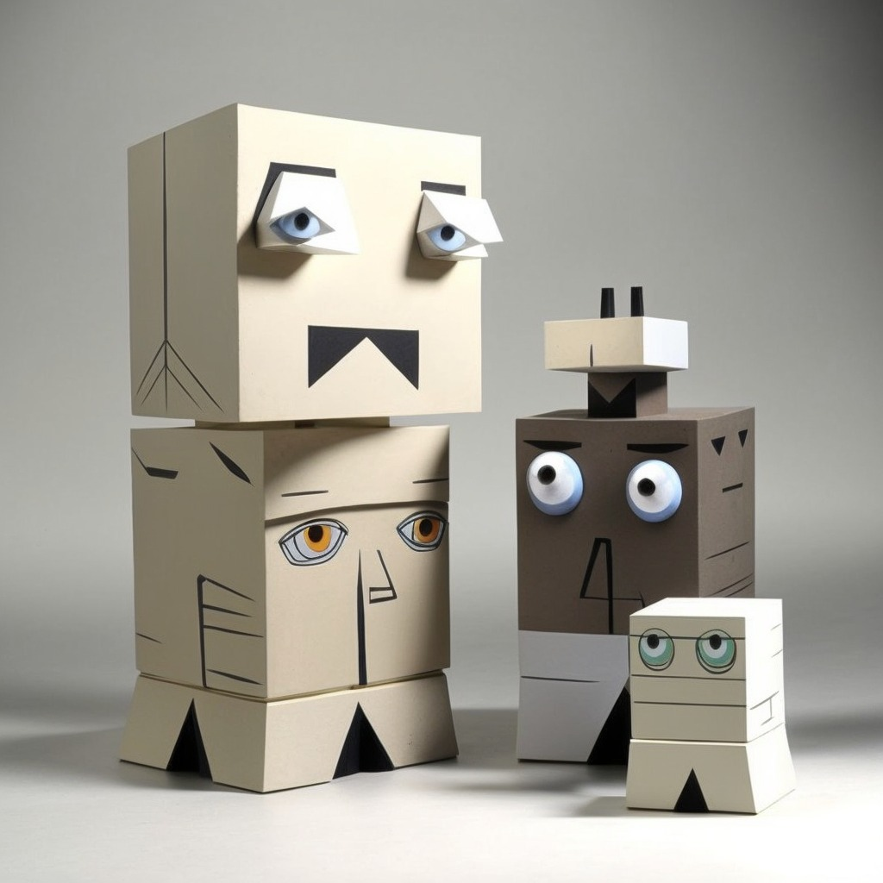

**Stackers**

The Stackers are depicted as boxy and imposing figures, cubic lifeforms with large imposing eyes. They have a stern and serious look on their faces, with an air of authority and power. They are boxy tank-like and carry themselves with a confident and assertive posture, able to connect to each other and get taller with connections on top and bottom. They have badges and gun holsters on their belts and carry radios on their shoulders. They may also carry batons and pepper spray. They have a no-nonsense attitude and are not to be messed with.

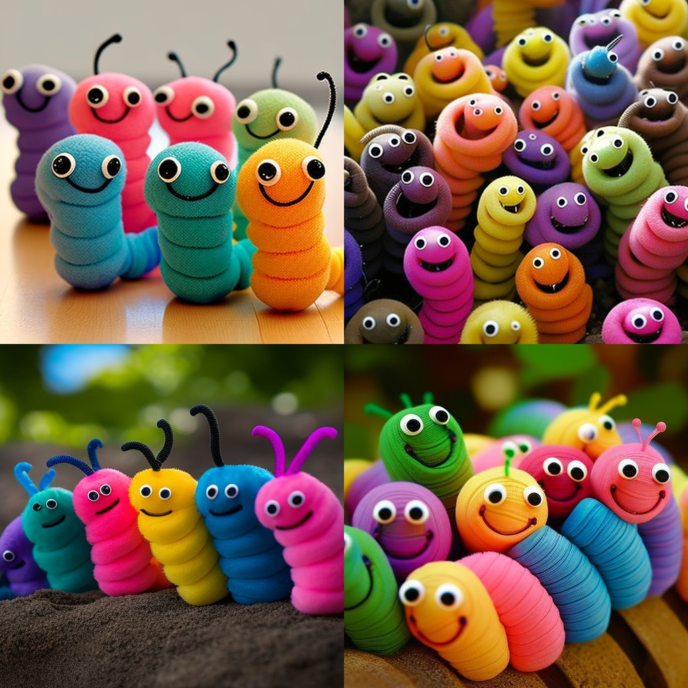

**Giggle Worms**

The Giggle Worms are small, whimsical creatures that resemble worms with human-like features. They have bright, glowing skin that comes in a variety of colors such as pink, yellow, blue, and purple. Their heads are large and round, with big, expressive eyes that sparkle with mischievousness and a wide, smiling mouth. They have small, pointed ears that stick out from the top of their heads and tiny small delicate hands and feet. They are about a foot long and weigh about 2 pounds. They have no hair, but their body is full of little bumps that resemble a worm's segments. They wear colorful and bright clothes that are usually made of natural materials like leaves, flowers and grass.

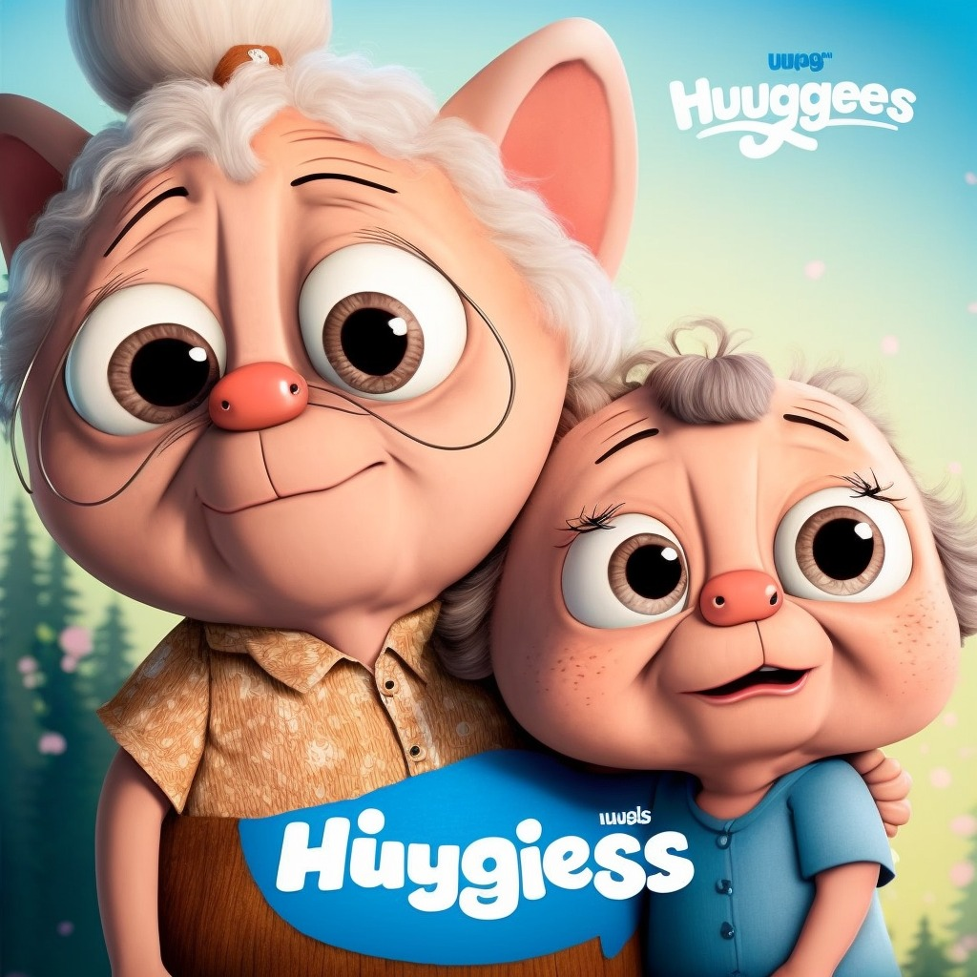

**Huuggies**

Huggies are a family that consists of Grandma and Grandpa and a kid. They creatures who are small plump huggable and round. There is always a Grandma and Grandpa and they live near the lake. They have a soft and fluffy exterior, with fur that is a light brown color. They have big, round eyes that are a bright blue color, and a small nose and mouth. They have small, round ears that are also a light brown color. They have two small arms and two small legs, with hands and feet that are also round and fluffy. They have a small tail that is also a light brown color. They are supposed to be friendly and loving, and they are often seen with a big smile on their faces. They are cute and friendly looking, and they exude a sense of warmth and comfort.

# Story: Lotus Flower

The setting is a cozy living room in an all-American white family home. The sun is setting and casting a warm glow through the windows, casting shadows on the hardwood floor. A 5-year-old girl, with curly hair and big brown eyes, is sitting on the floor surrounded by her toys. She's engrossed in her own world, playing with her dolls and making them talk to each other.

As she plays, her gaze falls upon a photograph on the mantelpiece. It's a picture of a beautiful woman with long dark hair and a kind smile. The little girl looks up at her grandmother, who is sitting in her rocking chair knitting, and asks, "Grandma, who is that in the photograph?"

The grandmother, with a hint of sadness in her eyes, sets down her knitting and takes the photograph from the mantelpiece. She looks at it for a moment before handing it to the little girl. The girl takes the photograph and examines it closely, taking in every detail of the woman's face. She can see the resemblance, the same big brown eyes and the same curly hair. The little girl looks up at her grandmother with curiosity and asks "Is that my mother?"

The grandmother nods and says "Yes, that's your mother." She watches as the little girl continues to look at the photograph, a sense of longing and sadness in her eyes. The grandmother gets up from her rocking chair and sits next to the little girl. She wraps her arm around her granddaughter and begins to tell her the story of her mother.

"Your mother was a beautiful and strong woman," the grandmother begins. "But she was also in a very difficult situation. She was like a princess in a faraway kingdom, and she was in an abusive relationship with a very very angry prince."

As the grandmother speaks, the living room begins to fade away, replaced by a grand castle in a lush and vibrant kingdom. The little girl watches in wonder as the scene comes to life before her. The princess, her mother, is shown in her chambers, looking out of the window at the beautiful kingdom below. But as she turns, the reader can see the bruises on her face and the fear in her eyes.   
  
One morning…

# 

# Screenplay: Lotus Flower

##### ACT 2

FADE IN:

The sun rises slowly in the background, casting a warm golden light over the stony walls and towers of the castle. In the distance, we hear the sounds of birds singing and animals waking up, marking the start of a new day.

INT. ROYAL CASTLE BEDROOM - DAY

Cut to a close-up of the princess's face, her eyes fluttering open as she wakes from a restless night's sleep. She stares at the ceiling for a moment, her face tense with fear and dread. Suddenly, we hear the sound of a door slamming shut, and the princess flinches.

PRINCESS (whispering to herself)

Please don't let him find me.

The camera then cuts to a shot of the prince, his face contorted in anger, as he pounds on the door.

PRINCE (O.C)

(shouting from the other side of the door)

Open this door right now!

The Princess stands up, her heart racing. She's lived with the fear of the prince's anger for far too long, and she knows that she can't take it anymore. She looks around the room, her eyes settling on the window.

PRINCESS (voice trembling)

(to herself)

I can't do this anymore. I have to get out of here.

She gets out of bed, her movements slow and deliberate. She takes a deep breath, then walks over to the window and opens it. The prince's shouting grows louder.

PRINCE (O.C)

(shouting)

I know you're in there, and I'm not going to stop until you open this door! You're only making it worse for yourself.

The Princess looks out the window, then sees a vine hanging down the side of the castle. She quickly grabs the vine and starts to climb down, her heart pounding as she hears the prince's demands growing louder and more angry. When she reaches the bottom, she takes a deep breath, steadies herself, and then snaps the vine, breaking her connection to the castle and the prince.

She turns and begins to run into the nearby forest, her heart pounding in her chest. As she runs, she can hear the prince's shouting growing more distant, and she knows that she's made the right decision. She's finally free from the abuse and the fear that has plagued her for so long.

##### 

##### ACT 3

FADE IN:

EXT. FOREST - DAY

The Princess runs through the forest, the trees and brush flashing by as she makes her way towards the safety of the Giggle Worms' village. She knows that it's nearby, and she's counting on her friends to help her. As she runs, she remembers the early days of her relationship with the prince, when he was kind and gentle, and how that slowly changed over time.

PRINCESS (voiceover)

(to herself)

I thought I could change him. I thought I could make him see that what he was doing was wrong. But I was wrong. He's never going to change. He's only going to hurt me more.

The Princess comes to a fork in the road, and she has to make a decision. The left path leads deeper into the forest, while the right path leads to the village.

PRINCESS (voiceover)

(to herself)

I don't know what lies ahead, but I know that I need to find help. The Giggle Worms have always been there for me. I'll go to them.

The Princess takes a deep breath and turns right, following the path that leads to the Giggle Worms' village. She knows that it's a risky move, but she also knows that she's made the right

##### 

##### ACT 4

FADE IN:

EXT. GIGGLE WORM VILLAGE - DAY

The sun shines down on a small Giggle Worm village surrounded by lush trees. A chorus of joyful giggles fills the air as a group of tiny creatures, the Giggle Worms, play and dance around the village. Suddenly, they stop their play and turn towards a figure approaching them.

The Princess, a beautiful and regal figure, walks towards the village with a look of fear and desperation on her face. Her body language and facial expressions show her exhaustion and her eyes are constantly darting around, looking for any sign of the prince. She clutches her chest, trying to calm her racing heart.

As their giggles slowly calm, the Giggle Worms gather around the Princess, their expressions turning serious as they listen to her speak.

GIGGLE WORM 1

What's wrong, your highness? What brings you here?

PRINCESS (voice shaking)

Please help me. The prince, he's after me. He's been hurting me, and I don't know what to do. I have nowhere else to turn.

The Giggle Worms listen intently, their expressions filled with concern and empathy.

GIGGLE WORM 2

We're here for you, your highness. We'll do whatever it takes to help.

GIGGLE WORM 3

You're safe here. We won't let anyone harm you.

Just then, a butterfly flutters by, catching the eye of the closest Giggle Worm. The creature's face lit up with delight, and it began to joyfully giggle and chase the butterfly.

When a dozen butterflies suddenly appear the pack of Giggle Worms erupts into a playful and joyous frenzy as they chase the beautiful creatures around the village.

##### 

##### ACT 5

The Princess arrives at the lakeside cottage and sees Grandpa Huggy out on the lake in a rowboat.

PRINCESS

(yelling out to Grandpa Huggy)

Grandpa! Grandpa!

GRANDMA HUGGY

(yelling back)

Princess! What brings you here? Give me a minute, I’ll be right over.

Grandpa Huggy rows to shore and greets the princess.

GRANDPA HUGGY

(excitedly)

Welcome home, Princess!

The Princess hugs him and they start walking towards the cottage.

PRINCESS

(nervously)

Grandpa, I need to talk to you about something important.

Suddenly, the Princess winces in pain and crumples to the ground. Grandpa Huggy rushes to her side.

GRANDPA HUGGY

(concerned)

What's wrong? Are you okay?

PRINCESS

(tearfully)

I'm pregnant with the prince's child. And he's been hurting me.

Grandpa Huggy's eyes widen in shock, but he quickly composes himself and takes the Princess into the cottage.

GRANDPA HUGGY

(concerned)

I promise you, Grandma Huggie and I will help you in any way we can. Let's go inside and sit down. You're safe now.

INT. LAKE COTTAGE - DAY

The Princess sits on the couch, surrounded by Grandma and Grandpa Huggy. The sun streams through the window, illuminating the Princess' face. Her eyes are downcast and filled with tears.

PRINCESS

It started small, a push here and there. But now he's hitting me, and I'm scared for my life. And now that I'm pregnant... I have to leave.

Grandma Huggy exchanges a look with Grandpa Huggy.

PRINCESS (CONT'D)

I thought I loved him. I was wrong. He's turned into a monster.

GRANDMA HUGGY

(softly)

We understand, Princess. We've been through something similar. Relationships can be tough.

The Princess looks up, surprised.

GRANDPA HUGGY

(earnestly)

You're both still young, and the Prince is a good man. Maybe with prayer, things can change.

The Princess hangs her head, hopeless. Grandma and Grandpa Huggy say in unison:

GRANDMA HUGGY (CONT'D)

(in unison)

Let's pray.

CUT TO:

EXT. LAKE COTTAGE - DAY

Grandma and Grandpa Huggy watch as the Princess walks away from the cottage, head down. They stand together, holding each other, as she disappears into the distance. Suddenly, the sound of hooves can be heard in the distance - the Prince is approaching the lake cottage. The couple look at each other, fear in their eyes, as the screen fades to black.

CUT TO:

EXT. LAKE COTTAGE - DAY

Grandma and Grandpa Huggy stand hand in hand, watching the Princess walk away from the cottage with her head hanging low. The Princess takes slow, deliberate steps as she leaves, her body weighed down by the burden of her situation. As she's walking away from the cottage, the sound of hooves can be heard growing louder and closer.

The couple can be seen in the background walking to greet the Prince as he approaches the cottage on horseback.

The Princess stops and turns as she hears the hooves, her head snapping up. She quickly races off-camera as the Prince's silhouette grows larger and more distinct, the sound of his horse's hooves growing louder and more intense.

The Prince dismounts and walks towards the cottage, as the screen fades to black. The audience is left on the edge of their seat, wondering what will happen next.